**Generalizing PRE’s variable importances to model-based trees**

**Computing rule importances**

Say, we obtained the following tree with constant fits: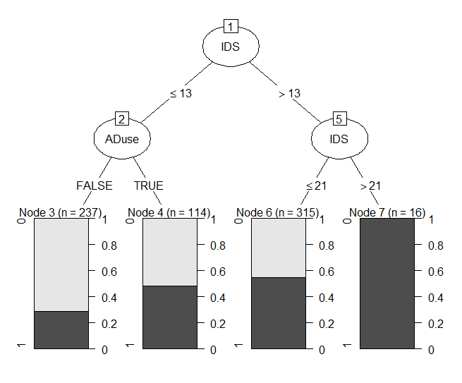

|  |  |  |  |
| --- | --- | --- | --- |
| 0.30 | 0.50 | 0.60 | 1.00 |

This tree has created four new variables:

R3(x) = I(IDS ≤ 13) & I(Aduse == FALSE)

R4(x) = I(IDS ≤ 13) & I(Aduse == TRUE)

R6(x) = I(IDS > 13) & I(IDS ≤ 21)

R7(x) = I(IDS > 21)

Each of these variables obtains a partial regression coefficient *b.* We can standardize this coefficient:

$b_{j}^{*}=\frac{b_{j}⋅SD_{r_{j}}}{SD_{y}}$

Not problems:

* Dividing by SD of y is only useful if we want to compare difficulties between different latent traits and/or datasets, so not necessary.
* The SD of the rule is pretty easy to obtain. No standardization issues there.

Potential problems:

* We need to have an intercept / reference group? In raschtree, this would be a reference set of item difficulties.
* The coefficient of the rule with Raschtree will be a vector of item difficulties. With a 2PL tree, it is two vectors: item difficulties and item discrimination params. Does importance need to be a scalar, or do we want to obtain an importance for each item?

**From rule importances to variable importances**

Once we have the importance of the rule, we assign variable importances by distributing the rule importances to each of the variables involved in the rule.